SECOND QUARTER OF 2018 EMA MINISTRY UPDATE
Salutation: The EMA Director and team of church planters extend our heartfelt greetings to you our Beloved Brethren. You are indeed part of us and very near to us than we can imagine. We do see you in the Spirit as you offer prayer for us in the ministry here and through your partnership in very lovely ways to assist us advance the building of God’s Kingdom on earth and specifically in Ghana. We see you drawing closer and closer to us each time as we remember you deeply in our hearts, as we also pray for you – for your lives, ministry and work places. There is much to rejoice concerning this lively relationship with you. We thank the Good Lord for your lives. We beg to share a bit about what the Lord has done in our small ministry in during this period.
Palm Sunday & Child Dedication at Techiman
The Easter event began with the celebration of the Triumphant Entry of Jesus Christ into the city of Jerusalem – Palm Sunday. As EMA Director, I continue to visit EMA old and new ministry stations to offer encouragement and to sensitise the leaders of local churches to be actively involved in evangelism and church planting. So I went to Techiman and whilst there, I assisted the church here to observe Palm Sunday event. A new ministry point is planned for Aboaso, a suburb of Techiman and plans are being made get this started this year. I assessed possibility of such a venture and all is positive. On Sunday 25 March. I preached from Matt. 21: 1- 11 on the theme, “Receive Jesus the King of Kings.” I made a comparison between the Kingship of Jesus and the kings of this world who ride on horseback or motorcade and regalia. The Kingdom of God is the rule of God in the lives of believers. Jesus kingship is that of humility as foretold by the Prophet Zechariah in 9: 9. I reiterated that everyone must receive Jesus now on earth during his / her life time or face Him as the ultimate Judge on the last day. The entire congregation waved their palm fronds and praised Jesus as King of kings. At the end of the message, Mr. Kwesi Gilla, the man who asked us to dedicate his child that day was touched such that he stood up and asked for prayer so that he will be able to wholly commit his life to Jesus Christ. I led him to pray the sinners’ prayer to invite Jesus into his life and he did so. He promised to come to church meetings each Sunday. He came to church the following Sunday.
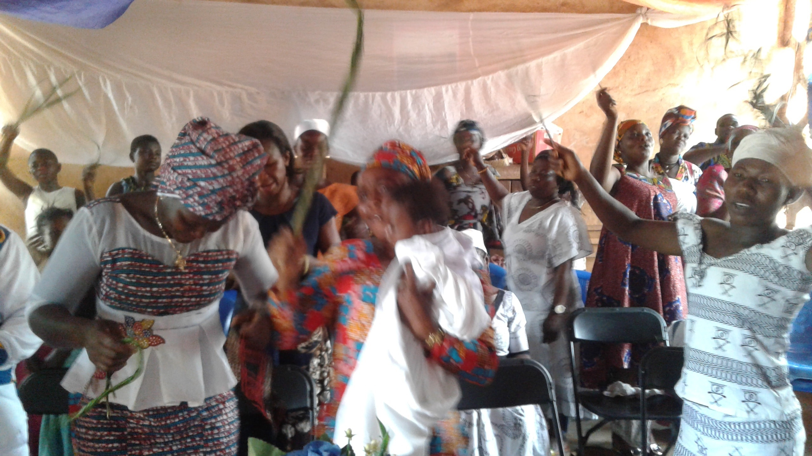
Techiman – praises and worship on Sunday
I then dedicated the child who was named Andrews Gilla, after a short message from Mark 10: 13 -16. I challenged the congregation to avoid names that could cause problems to the character of their children such as Judas Iscariot, and Ahap. The parents of the baby, Kwesi & Vivian Gilla were very excited about the event. I personally rejoiced because the entire church has believed the divine providence of children so that they want to dedicate these to God.
Meanwhile the Techiman ministry continues to grow in numbers and in spiritual maturity each week. During these visits, I have met seen some newcomers who have recently joined the church. Some of these have been baptised because of their faith in Jesus. They include Alima Yakubu, Stella Moadewe, David Badiamo, Baba Kunsoli and Patience Nyaba. All of them are growing in the faith.
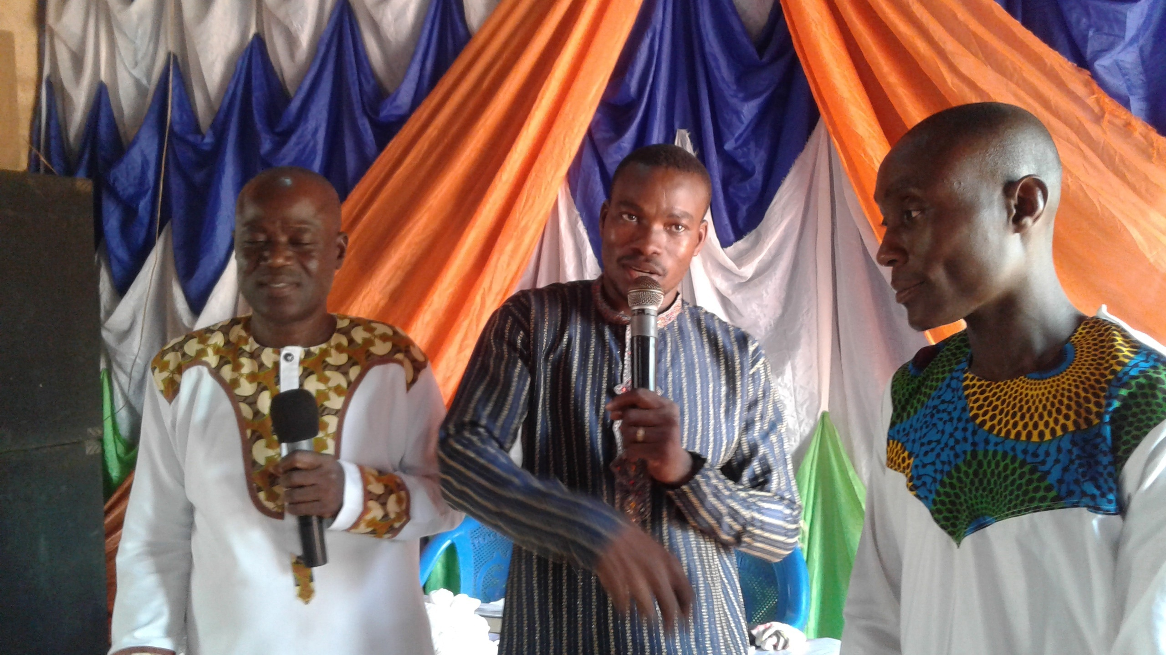
Kwesi Gilla, (right) prays to receive Jesus as Lord and Saviour
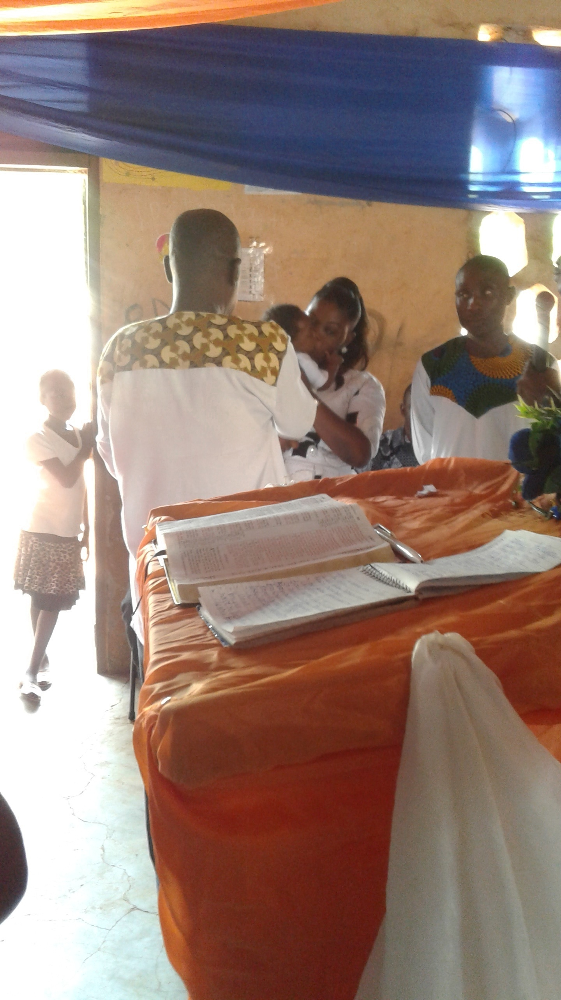
Rev. Thomas Abugah dedicates Andrews Gilla – Kwesi & Vivian take vows.

Easter Convention at Atwima Koforidua on 29 Maarch to 1 April 2018
The 2018 Easter event was held at Atwima Koforidua, a town situated about 10 kilometres to the west of the city of Kumasi. All the local churches started by EMA church planters in Kumasi area converged at this venue for the event on Thursday 29 March. The theme was, “The power of the Blood of Jesus Christ builds Contagious Churches.” I spoke on Friday emphasising the Significance of the Death of Christ and the role in planting contagious churches – that is believers who are able to “contaminate” the world with the teachings and lifestyle of Christ. Contaminate is used in the positive sense here meaning to the change the world with good lifestyles. If Jesus had come but not died, then there would not be any Gospel to preach. Hence there would have been no salvation for humankind. That is to say, “no cross, no eternal life.” I referred to the inscription on a certain car in this city that reads, “No Cross, No Crown.” Other cross references include Gen. 3: 16-19; Lk. 23. Tim. 2: 6; Heb. 7: 17-18; Heb. 8: 6-10; Jn. 8: 32. I challenged those without Christ to believe in Him and there was a good response.
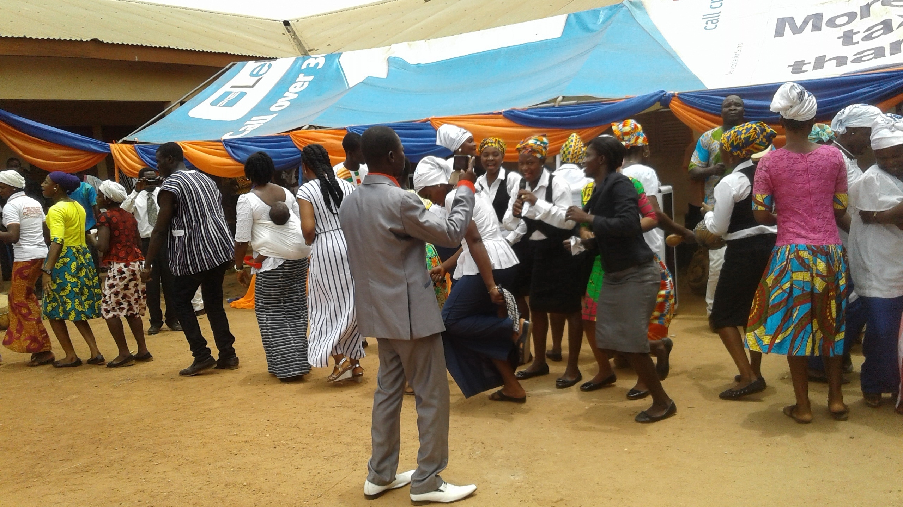
Atwima Koforidua Easter meetings- cross section 1 of praises time
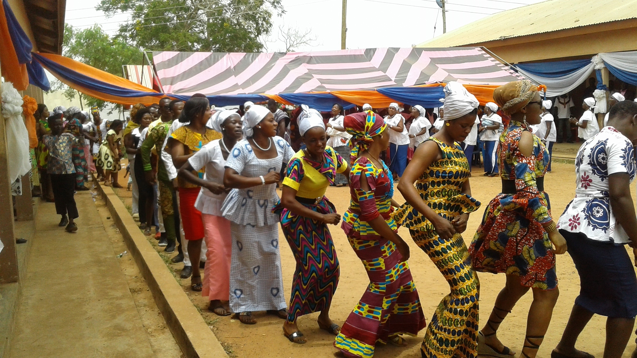
Easter convention at Atwima Koforidua –cross section 2 of praise time
We did a registration of participants who attended the event for the 3 days and by the close of Saturday, the names of 400 adults were in our books. The number of children were about a hundred but not registered. On Sunday more joined us but we did not register them. It can be deduced that close to 500 adults came for the event and all heard the Gospel message preached. The response was great.
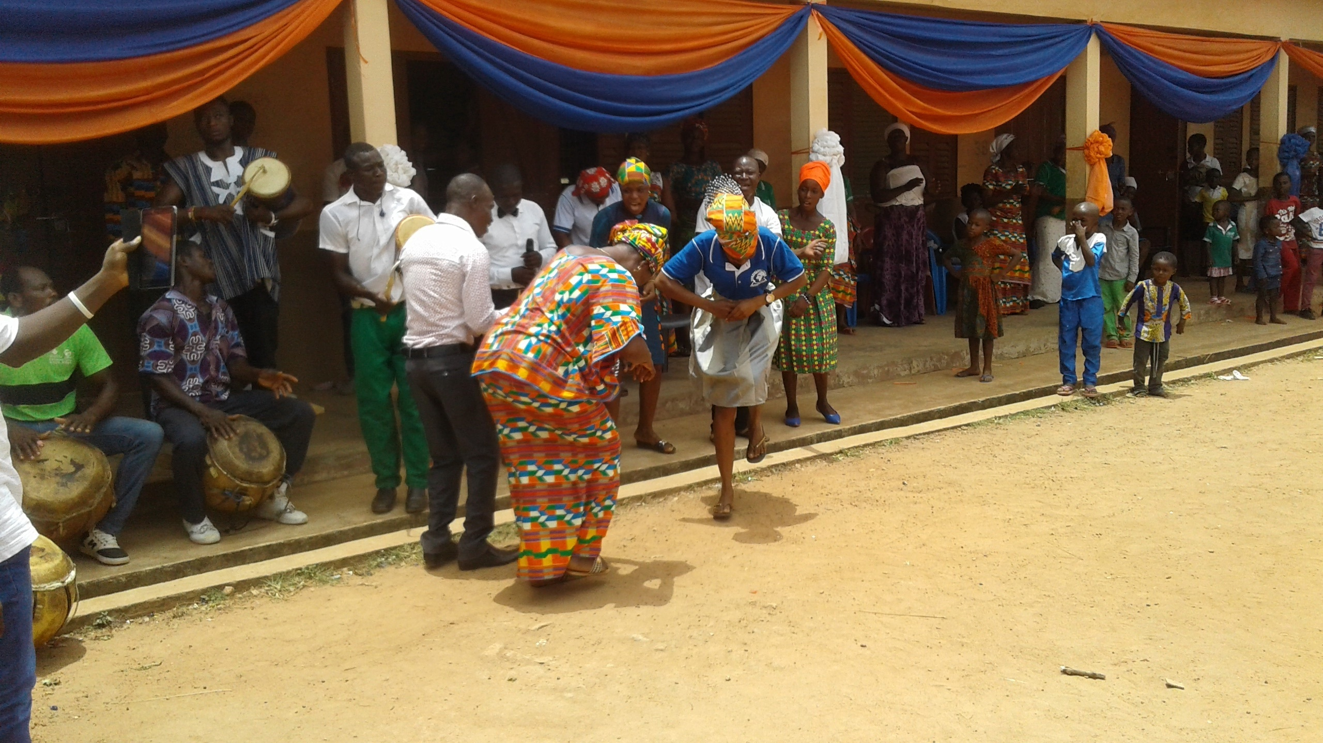
Easter meeting at Atwima Koforidua – Elizabeth & young lady dance to music
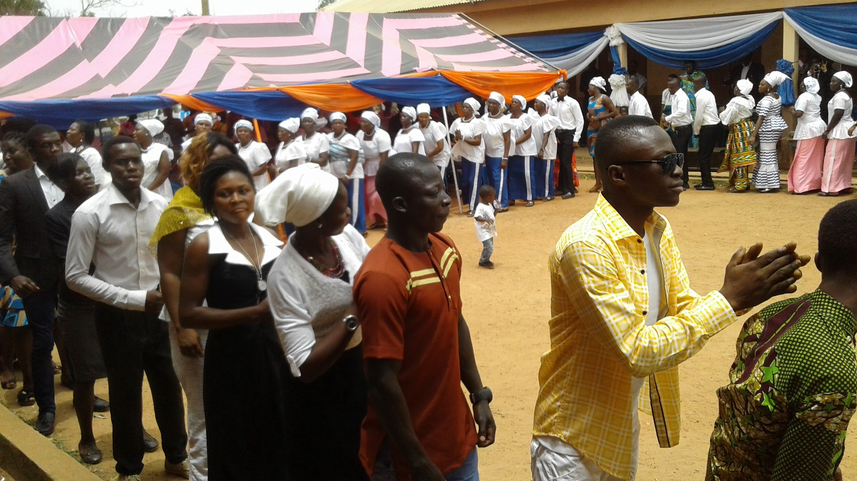
Easter Meetings at A. koforidua- cross section 3 of praises time.

Children’s Easter Meetings: The children were not left out but had a separate meeting and their teachers included Gilbert Bawobayi, Philip Adinbe, Georgina Asaa and Gifty Ayeriba. They taught the children some scriptures to memorise. In the afternoon, the Youth organised a Bible Quiz using portions from the Book of Hebrews. It was quite challenging and interesting as each local church rubbed shoulders to get the ultimate prize. This had to be continued on Saturday to get a winner. Peace emerged winner followed by Hope and they were presented with prizes. The losers also got some consolation prizes. The event spurred the youth to study the Bible daily and not to read it as a story -book.
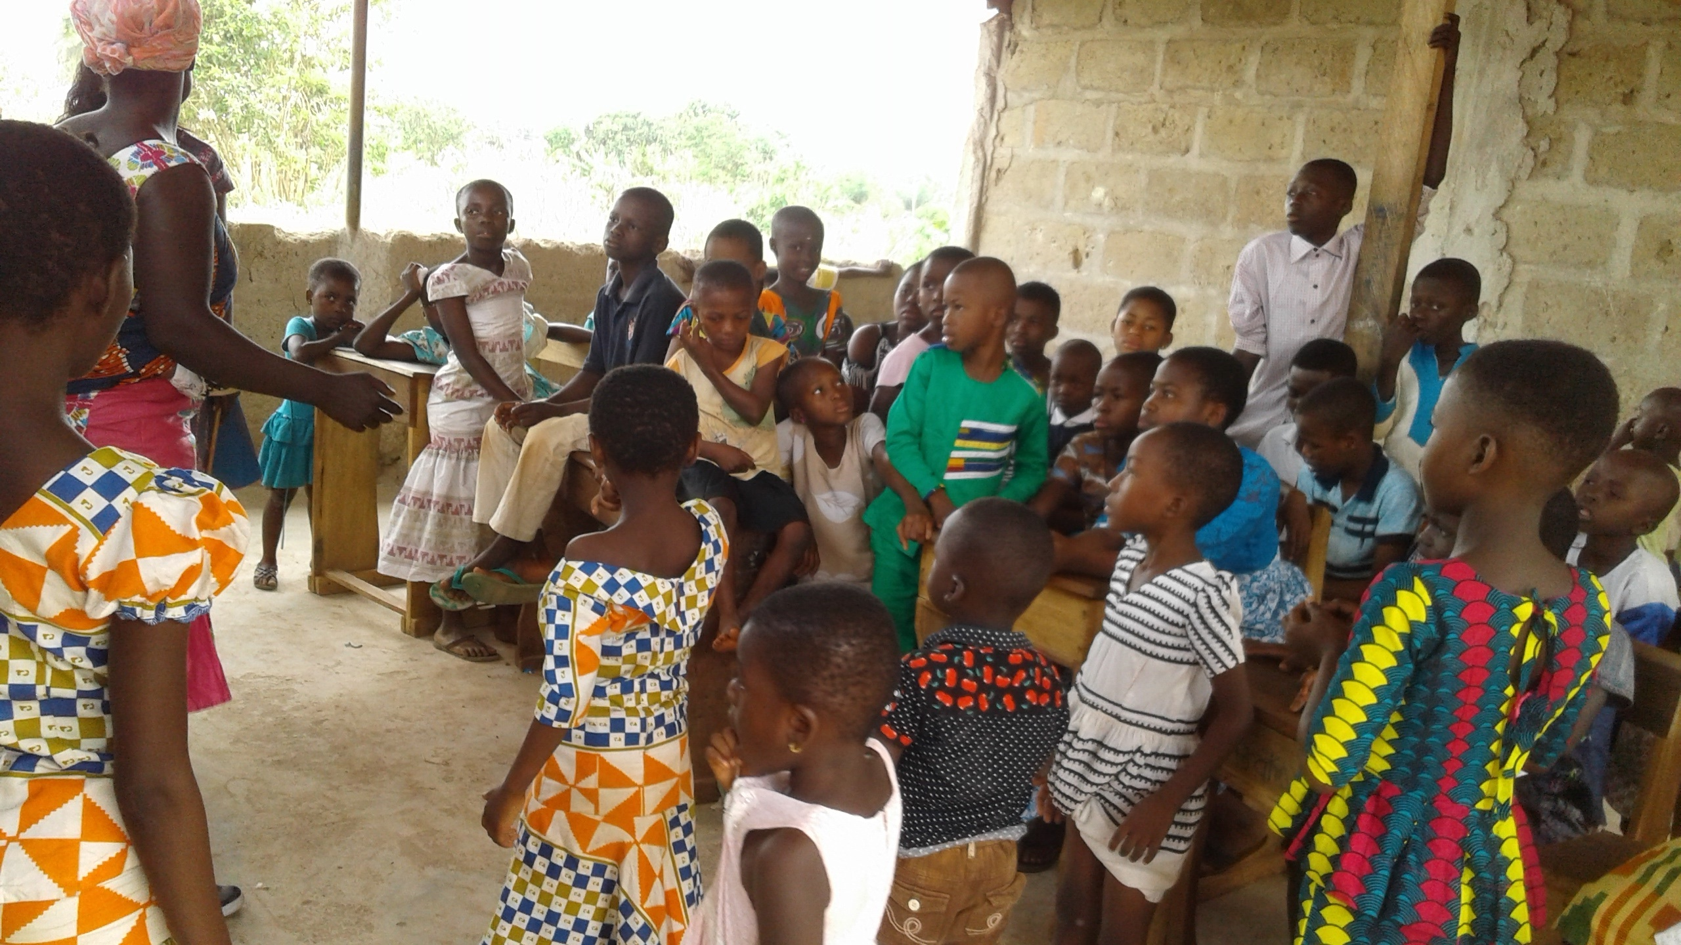
Easter convention – cross section of children’s meeting
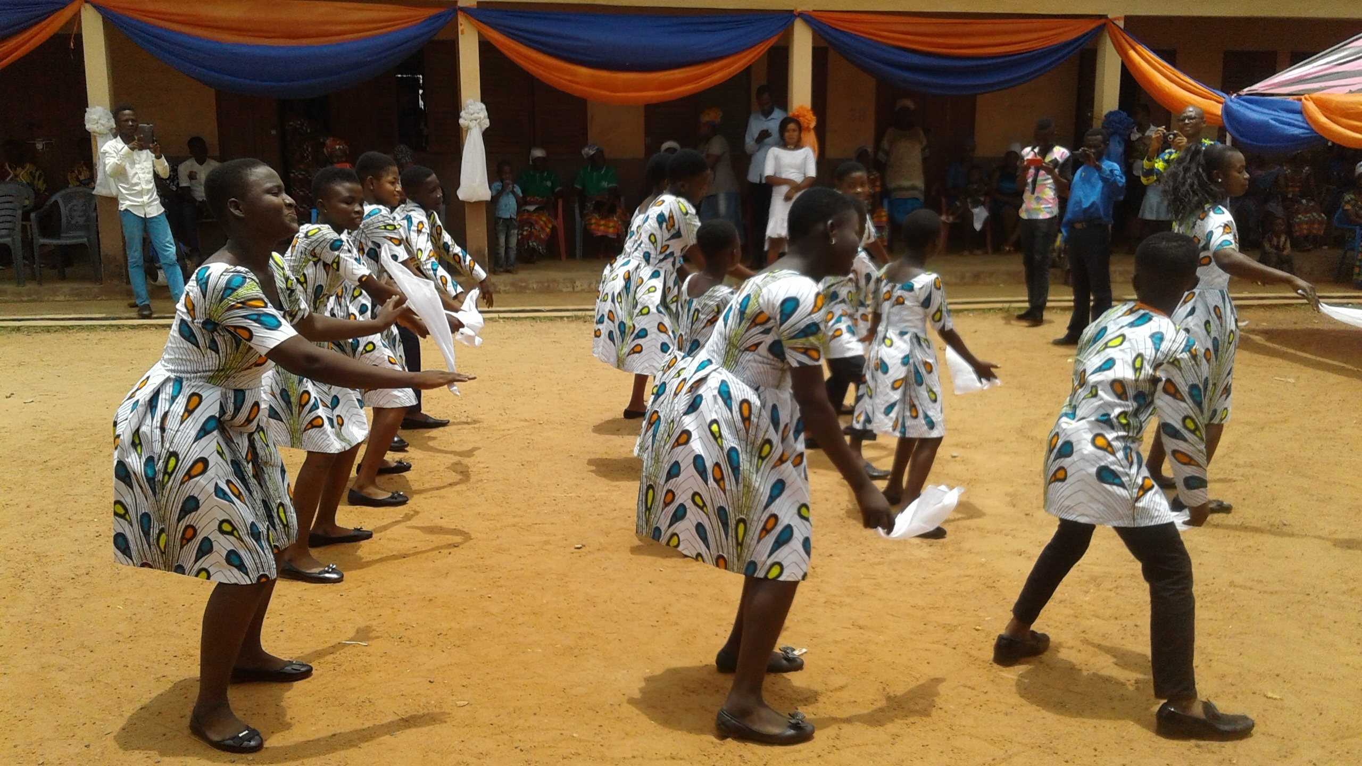
Faith Children perform choreography at Easter convention.
On Saturday, another speaker, EMA missionary, Thomas Pwalia did the teaching on “how to plant and build contagious churches.” He referred to living like Jesus, giving, engaging in retentive evangelism and others. These were practical lessons and very helpful. The response here too was good. In the afternoon, we sent out groups who did house to house evangelism. The leaders brought back some good reports .The response was good and about 60 names / contacts were brought to us and we have compiled these names and requested the host church to make a fruitful follow up on them. Four of the contacts came to the Sunday meeting and I talked to them. They promised to be at church services each week.
Sunday was the climax of the event. We started the day with a baptism at which 26 new believers made through the ministry were immersed at the river. Five believers from Mankranso were immere that day but five others from this group could not be immersed that day. We have planned to immerse them later. On return, the service started and I preached on the theme, “The Blood of Jesus shall raise you from the dead.” Reading from Luke 24:1-12 and 1Corinth. 15: 1-8; 50-58, I told the congregation that the resurrection of Christ makes Christianity unique. All those who claim to have started notable religions such as Islam, Buddhism, etc. remained in their graves. Only Jesus Christ overcame the power of death so those who believe in Him will be raised on the Last Day – 1 Thess. 4:13 -18. After the resurrection, Jesus appeared to many people to bear witness to this fact. I also pointed out that if there were no resurrection, then the faith of believers is based on nothing. The Apostle Paul says that in such a case we will be the most pitiful. There was a good response.
Children from Faith ministry danced to Gospel songs in the form of a choreography. Other children such as Stephen Bawobayi memorised long portions of scripture such as John 1: 1-10. I presided over the Lord’s Supper and after that, the meeting came to an official close. As we got feedback from those who attended the event, all said it was a meeting worth attending. We praise the Lord for this response. It was residential and some resources were expended in extending God’s Kingdom during the occasion
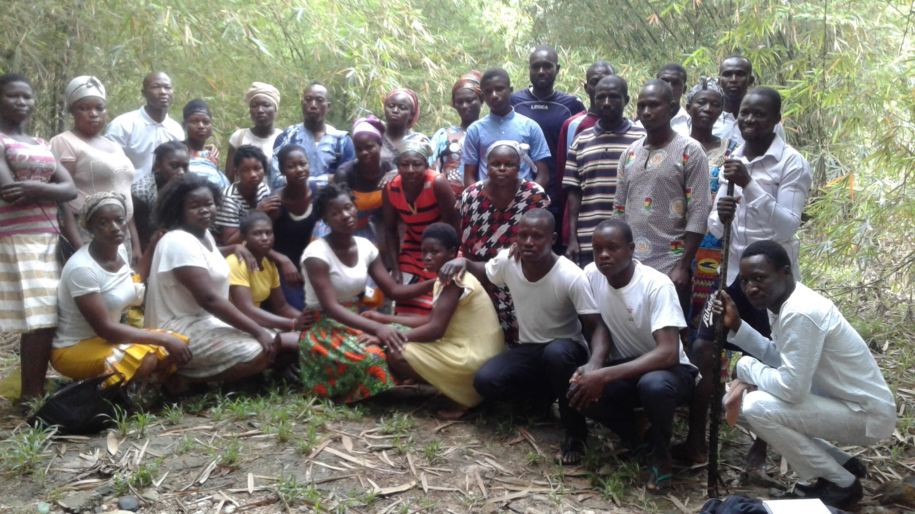
Easter convention – photo of baptism candidates at river before the immersion
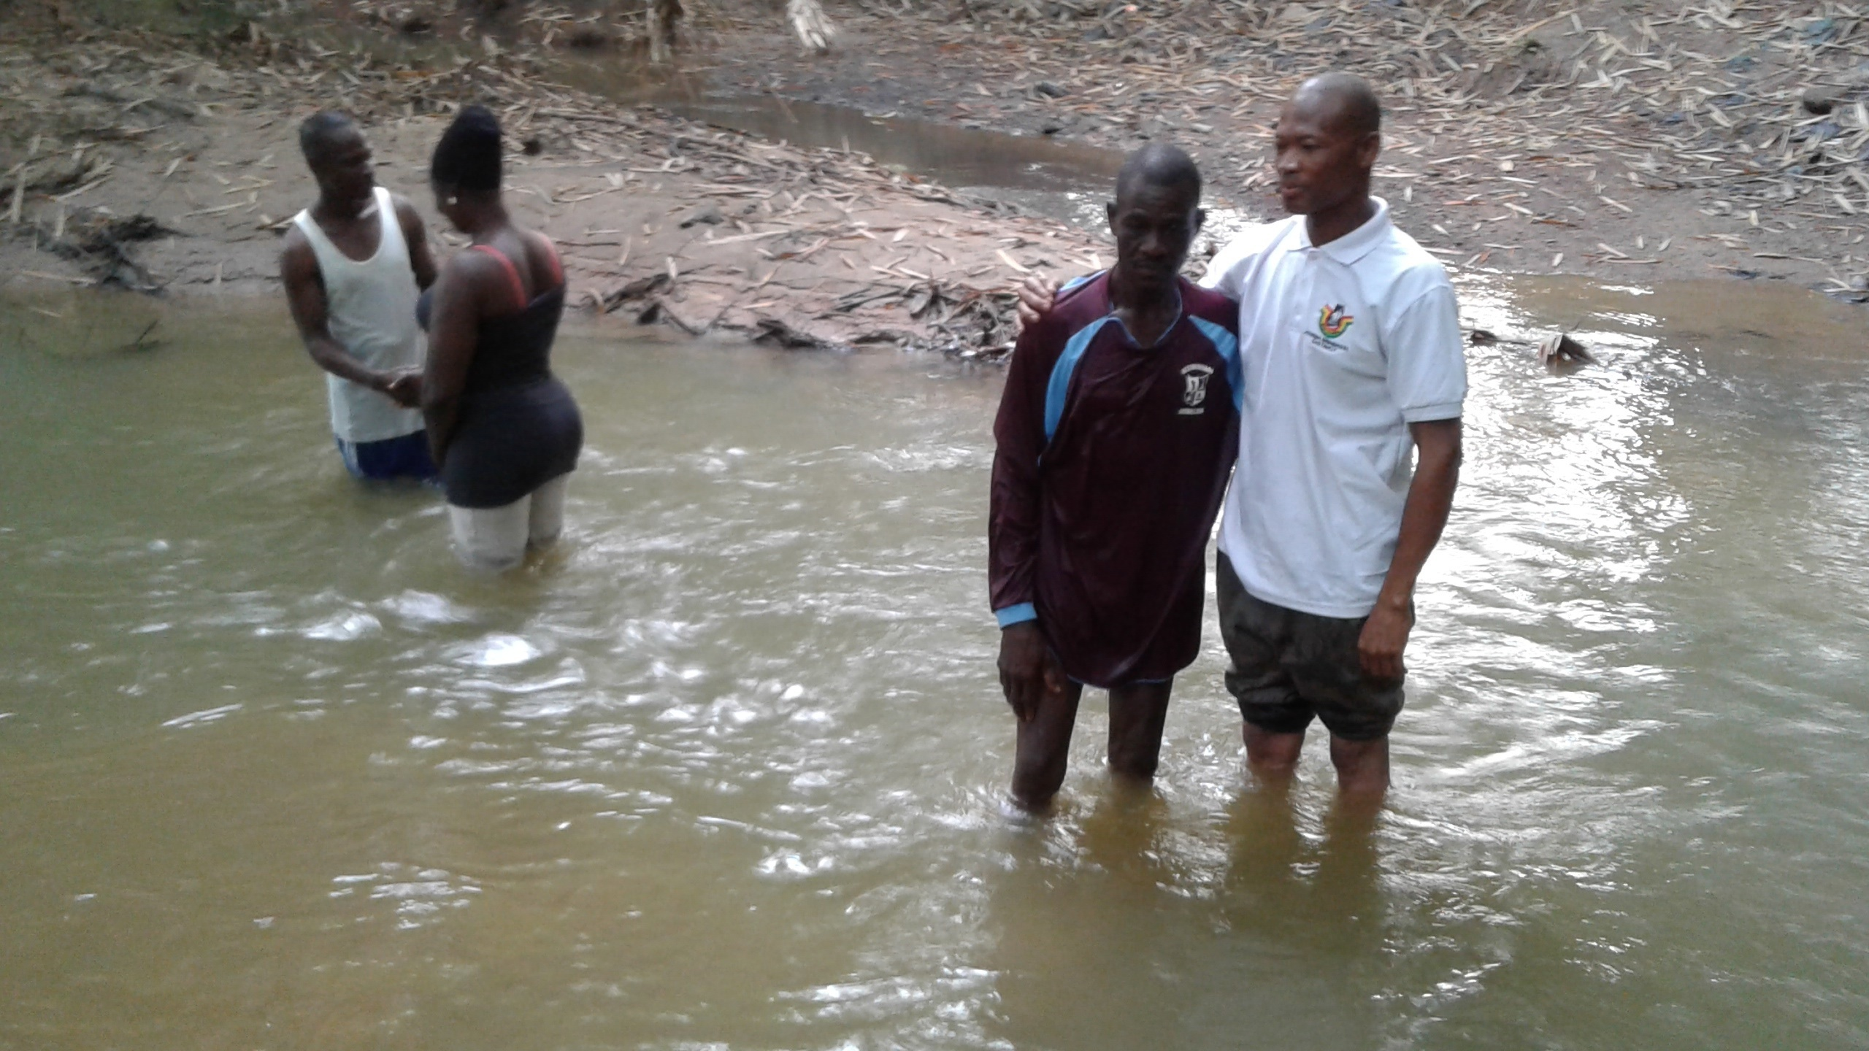
Easter convention – baptism of Abraham & Grace of Mankranso ministry
Ministry to Bodoworo and Ntanaso
I visited Ntanaso for ministry from 5 – 9 April. Simon and I visited Bodoworo again to encourage the new group. We visited most of the homes in the village and talked to them and asked them to put their faith in Jesus and also come to church meetings. They agreed to do so. We took the opportunity to talk to Tabariyiri & Doris Kumlanaga whose child I dedicated on the Sunday 8 April. On the day of our visit, they had asked friends to help them make some mounds for planting his corn. We could see that the farmers enjoyed their work and worked hard that day. Some of those we talked to at Bodoworo came to the service. After preaching from 1 Sam. 1, I made the couple to take the dedication vows. After this, we prayed for the child. The child was named Abel Kumlanaga. This couple have believed and were immersed in February with others as a testimony of their faith in Jesus Christ. They rejoiced in the the dedication of their child and gave thanks to God and those who attended the event. It will be noted that here, we use social / spiritual events such as child dedication / naming ceremonies and funeral services as effective channels for sharing the Gospel. The response is always good. Newcomers who attend such gatherings are moved to become members of the churches or preaching points.
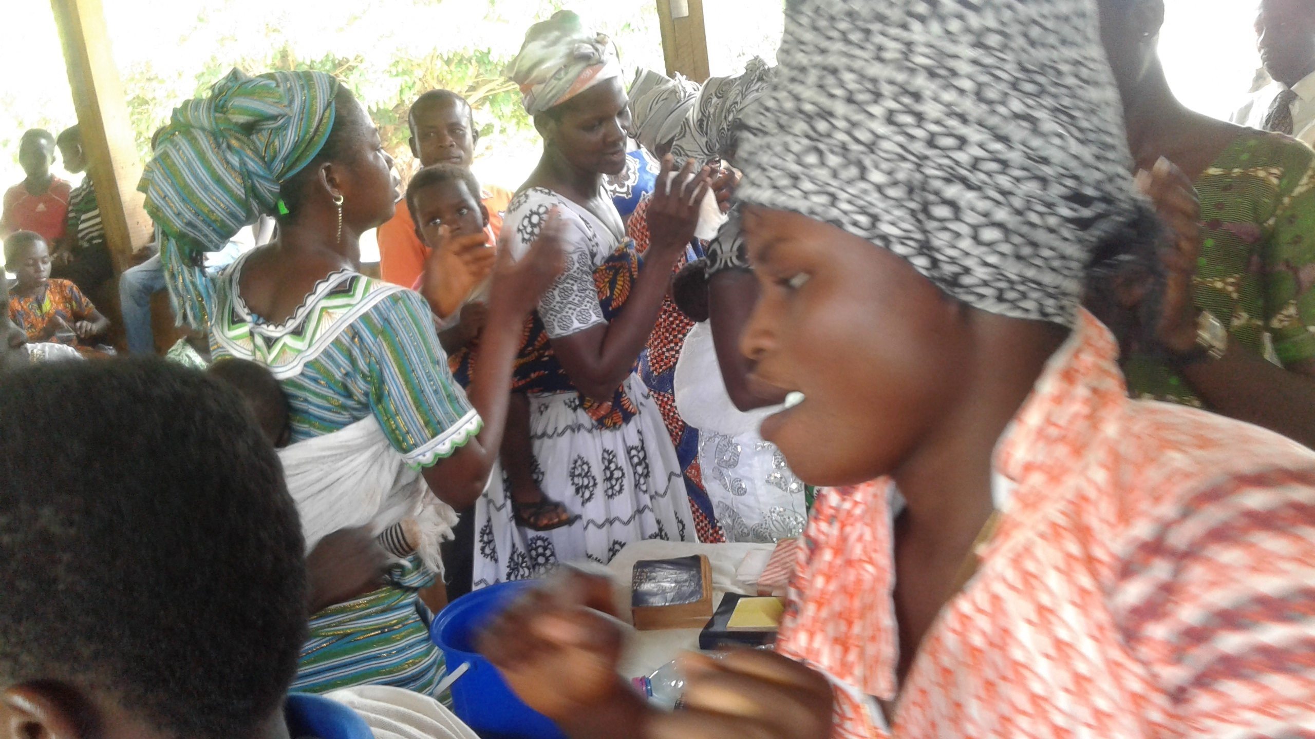
Ntanaso church service – praises time
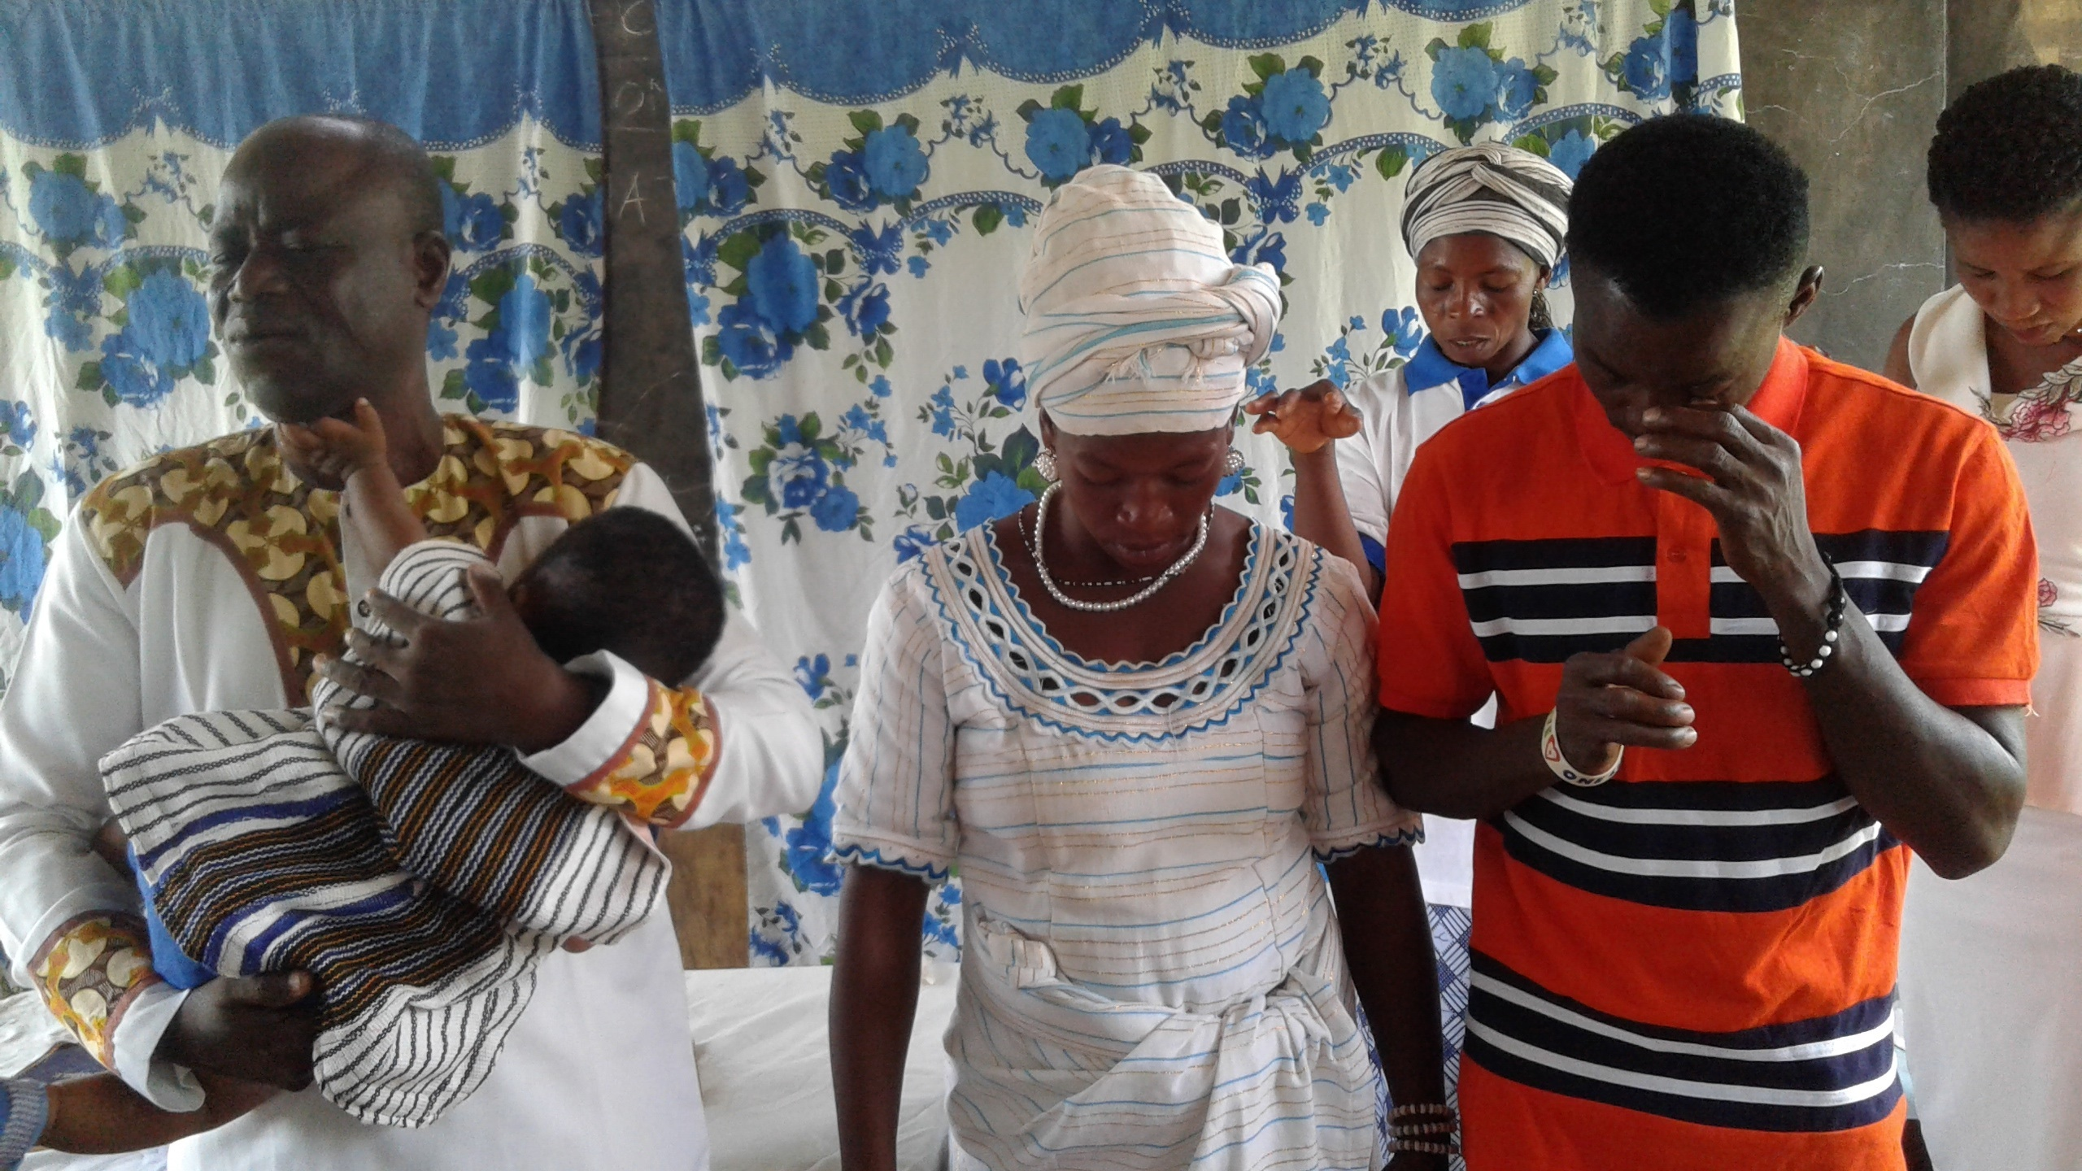
Ntanaso child dedication ceremony – Rev. Thomas dedicates Abel Tabariyiri.
For instance, some people from Bodoworo who attended the child naming and dedication event above have decided to be part of the church at Ntanaso. One Kwame Nwineasong, who received a healing touch on the left eye by God when I prayed for him in February stood up at the occasion and gave a good testimony. He then urged all those who are not part of the church to do so immediately as he has done.
Funeral Service:
As earlier said the period had been very busy for me. With the help of the church leaders and the family, we put together a funeral programme for late Georgina. I had to spend some time to get written biography / eulogy for the widower, and the church. On 27 April, we had a wake keeping in the night and 28 April was the burial service. Many sympathisers and well- wishers attended this solemn event. We could not have countered them but the estimate is over 500 adults. Consider this trend of events: on 5 July 2003 I baptised her when she made a confession of faith in Jesus. On 5 Aug. 2003, I officiated at her wedding ceremony. On 28 April 2018, I officiated at her burial service. That is worrying In any case, I preached from Gen. 2: 4-7; 16-17. On the theme, “Your Life is a loan from God” I challenged all to understand that no one can do what pleases the flesh because he / she feels life is a gift that can be used anyhow. On the last day we shall stand before the Judgement seat of Christ and all will account for how the loan God gave to each person has been utilised – for loss or for gain. -2 Corinth. 5: 10; heb. 9:27. I was helped by two other ministers- Revs. Thomas Pwalia and Daniel Ofosu Adjei at the burial service. It was a very solemn occasion. The mortal remains of the deceased were laid to rest. After this, the funeral continued in the afternoon at which sympathisers made various donations to cater for the costs incurred and for the upkeep of her children.
There was a Thanksgiving service on Sunday as it is common here. Please do pray for Daniel and the children and their education. The woman bore most of the burden but now she is gone.
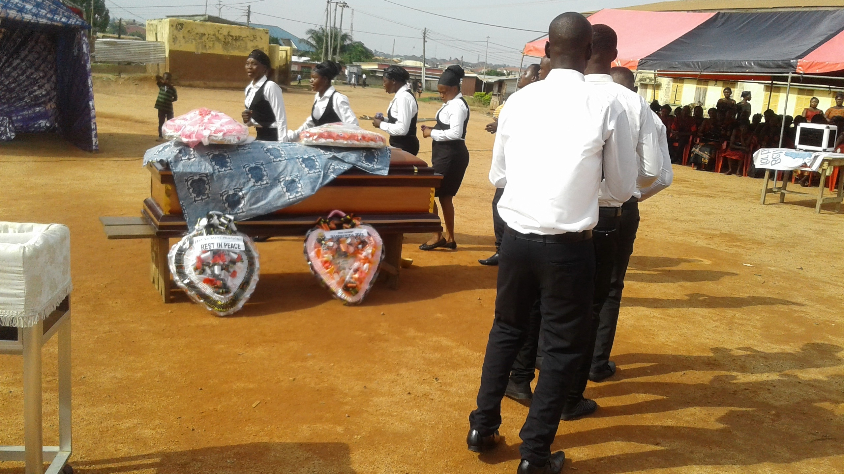
Georgina’s funeral – Victory Singers pay their last respect
Plans
i. I plan to visit Koforidua, the new ministry station, for evangelism and a baptismal service.
ii. Also visit Kunsu, the newest ministry station for evangelism.
iii. Hold a burial and funeral service for the young man John Kodewuyi on 12 May.
Prayer Requests:
- Pray for the bereaved families – Daniel and his children, Teni and his children.
- Pray for the funeral and burial preparations of the John Kodewoyi fixed for 12 May and for the finances involved.
- Pray for the new groups at Bodoworo, Poposo, and evangelism at Kunsu.
- Pray for the visit to Koforidua for ministry.
Conclusion: The gains are modest. There is yet a lot to be done in the months to come. Souls are dying without Christ. They need to hear the Gospel and make a choice. We determined in our own small way to make this happen and to contribute to the fulfilment of the Great Commission until He returns. We esteemed your partnership in this regard. Thank you many times for your partnership. May the Good Lord richly bless you.
Submitted by:
The EMA Director

