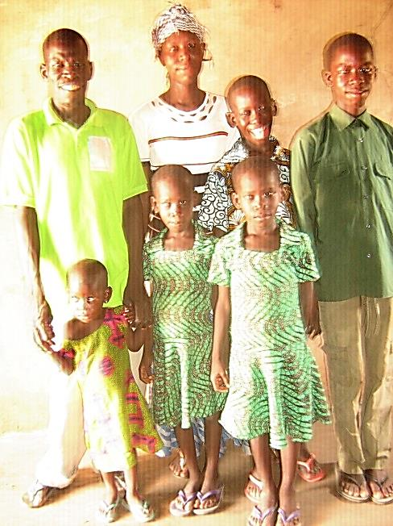**FOCUS ON JOSEPH AGANA – MAY 2015**

**EVANGELICAL MISSIONARY ALLIANCE MINISTRY FOCUS- VOL. 5**

Grace and peace to all friends / partners of the Evangelical Missionary Alliance (EMA). Calvary greetings from the Director, Staff, Board and all the missionaries on the field. We appreciate all your support in diverse ways to the ministry. We deem it a privilege to continue to introduce you to the missionaries and their ministries and to keep you abreast of what the Good Lord is doing through each of them. This is the volume 5 of the series and this focuses on Joseph Agana, his family and ministry. We pray and sincerely hope that you will enjoy reading each issue even as you pray and partner with us in building the Kingdom of God in the lives of people who might not have had the opportunity to hear the Gospel let alone to believe in it. In Romans chapter ten and verses eight through fourteen, the Apostle Paul categorically states the essence of “sending” as far as believing or appropriating the message of salvation in Christ is concerned.

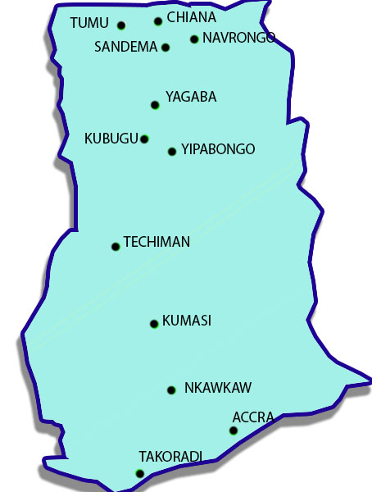Joseph Agana is a native of Kunkwa in the Bulisa South District of the Upper East Region. Joseph is married to Christi Adjoa Agana and they have five children. After becoming a Christian and serving his local church as a leader, he entered the Bible Training Centre in Chiana and completed the two -year programme in 1997. After Bible School, he had a call to missions. He responded to this call and relocated to Yageba to engage in cross -cultural missions, under the umbrella of EMA. Yageba is part of the Northern Region in the former West Mamprussi District of the Northern Region of Ghana. This area was popularly known as ‘overseas’ because the River Volta had cut off this area from other towns and villages in the Region. However, in the past few years, a bridge has been constructed at Kpesenkppe to create access to the town and others. Recently, the town has become the capital of the newly created Mamprugu Moaduri District. The people of Yageba speak Mampruli. By the grace of Jesus Christ, Joseph was able to learn the people’s language and culture and adapt to them. As a result he planted local churches in places such as Zamwara and Sageyaa. He was also able to bring up the young church at Yageba.

There are plans to relocate him to Gyadem a town to the east of Yageba from where he can share the Gospel with the following villages and towns: Seisa, Sakpaaba, Loagri, Prima and Kpasenkpe. He is currently mobilising the church Youth for evangelism and church planting. He will need financial support to do so and to also cater for the needs of his family - living expenses, health and children’s education.

**Praise and Prayer**

1. Praise the Lord for the local churches that have been started. Pray for their growth.
2. Pray for the resources to target the villages aforementioned.
3. Pray for the health of his family
4. Pray for the general finances of EMA
5. Pray for the Director even as he visits these and other remote places in June where the only scarce means of transportation is motor bikes and bicycles.

Thank you,

Rev. Thomas Abugah, EMA Director, P.O Box CT 710, Accra – GhanaWest Africa

Tel. +233-244-576829

Email: thomabuga@gmail.com