THE MINISTRY OF THE EVANGELICAL MISSIONARY ALLIANCE
The Evangelical Missionary Alliance (EMA) is the missions and evangelism wing of the Good News Bible Church. The leadership of the church had seen the need for the formation or inauguration of such ministry in the 1980s and meetings were held in respect of this. However, it was in May 1992 that EMA officially started operations under the leadership of Rev. Dr. Evans Laryea, the first director. Other members of the EMA Committee included Thomas Abugah and Raymond Lee. Ray represented SIM at the time. Official meetings of this committee were held in one of the rooms in the mission house of Tesano Good News Church. With time, the venue was later moved to SIM Office. With time the committee was renamed EMA Board.

PURPOSE OF EMA: To evangelise and plant local churches in response to the mandate given by the Good News Bible Church (GNBC). EMA exists to increase the number of local churches under GNBC.

VISION: To be the main organ under the GNBC that enhances the growth of the church through effective evangelism and the subsequent planting and multiplication of local churches.

MISSION STATEMENT: To actively sensitise local churches and individuals to the need for missions, recruit and train church planters and engage them in evangelism, especially cross culturally, and church planting amongst the unreached peoples.
Through such activities, the GNBC will be in the position to contribute significantly to the fulfillment of the Great Commission given by Our Lord Jesus Christ (Mat. 28: 19-20). in our generation.

OBJECTIVES: These can be seen in Articles 2B of the EMA Constitution / Policy Document. In summary are the ff:
- Creation of missions awareness amongst church members / individuals.
- Fostering closer relationship / collaboration with local churches towards the fulfillment of the Great Commission.
- To identify and recruit individuals with a call to and burden for the lost.
- To send out these into the ripe mission fields to gather in the harvest.
- To raise he needed funds to support the ministry
EMA is concerned with those who really have a heart for missions – who have a call from Jesus Christ to preach the Gospel with the ultimate view of making disciples. The intention of the missionary must of course be to start a viable church such that when he leaves the place for another mission field, it can stand on its own with good leadership. After evaluating a ministry, EMA Director and the Board have the responsibility to collaborate with the church planter and the District Church Council (DCC) for a possible transfer or relocation of that missionary.

EMA IN RETROSPECT
a. Administration: The chief executive officer of EMA is the Director who is assisted by the Board to execute his mandate. Since the official inception of the ministry, the following personalities have managed EMA as Directors: Dr. Evans Laryea, Stephen Antwi, Monday Amoak, Thomas Abugah and Edward Alemya. Thomas Abugah is the current Diector. Each of these made a contribution to the growth of the ministry.

b. Team of Missionaries: It is important to make a brief reference to the team of evangelists / church planters who have served on the field at different times. However, this is not meant to be an exhaustive list. They include: Monday Amoak, Martin Amoak, Thomas Abugah, Antwi Bosiako, Lawrence Asuavere, John Bosco Bawiah, Jacob Denjei, Norbert Ayaamo, Jonas Alandu, Michael Ayuekanbe, Boniface Akantoe, John Mensah Avoata, Edward Alemya, Edward Amolikado, Peter Dawuni, Joseph Agana and George Akumzidi. The rest are Titus Alo Apuri, George Babawedoe, David Achegiba, George Bayepakochoge, Godfred Augustt (Deaf Ministry), Thomas Pwalia, John Kampale, Emmanuel Yakijo, David Neindow. It will be helpful to mention that Eric Prah, Abukari Yakubu and Rahman Yakubu were seconded to work with EMA but their financial support came through a different channel.
Each of these has made a contribution to the mandate given to EMA.
Most of them are no longer with EMA. Those still serving with EMA are: Thomas Abugah (Director), Thomas Pwalia, Edward Alemya, Michael Ayuekanbe, Peter Dawuni, George Akumzidi, Edward Amolikado, George Babawedoe, Joseph Agana, John Kampale, Emmanuel Yakijo, David Neindow.

c. Evangelistic / Church Planting Activities: The main task of the EMA missionary is evangelism that leads to the starting of local churches. So we send church planters to a given area because there is a need for the people in that location to be discipled for Christ. They are expected to use suitable strategies to share the Gospel. These may vary as we move from one people to another. Experience has shown that literacy is a need in predominantly non-literate communities and this have been used to advance the course of the Gospel in time past. Some missionaries have also used cell / prayer and Bible study to plant local churches. This means that church planters continue to share the Gospel; with unbelievers. Missionaries are expected to engage in all or some of the following activities to evangelise and plant local churches:

- Geographical survey of the town or village. This will inform him of the strategy that is suitable.
- Religious survey to determine the various religions in the community, such as church denominations, Islam, African Traditional Religion and other faiths.
- Making a contact with the opinion leaders of the town or village and sharing the vision and mission with them. This is meant to draw their attention and get their support for the ministry.
- Target some homes or individuals that will lead to the beginning of cell groups and the sharing the Word on regular basis.
- The church planter challenges individuals to have faith in Christ. Those who confess Christ Lord and Saviour are baptised and organised into a local church.
- The church planter then starts developing some of the baptised converts as leaders within the shortest time.
- The church planter then officially hands over the group to the overseeing District Church Council and then moves on to another location on recommendation of the EMA Administration which is responsible for transferring missionaries.

d. Contributions to the growth of GNBC: Church Planters reports show clearly that their evangelistic activities have made some modest gains and contributed to the growth of the GNBC. The following is a list of some local churches started by the ministry: Zamwara, Bugisa, Mempeasem, Nangurima, Mankarugu,, Fianko, Winneba, Swedru, Kasoa, Cape Coast, Obom, Madina, Nkawkaw, Gbedem-Kunkwa, Kaadem, Nansa, Awulansa, Enchi, Nyame Boame, Victory (Asuoyeboa), Nkawie, Techiman, Ntanaso, Mim, Hope (Apramang), Peace (Abrepo), Atwima Koforidua, Yidan-Gongo, and Tangasugo (Burkina Faso). Others include Luisa, Kubugu, Fumbisi, Bilimonsa and Mim. This is not an exhaustive list of groups sarted via EMA ministry. In fact a few groups after their inception have suffered because of leadership problems and remain inactive These include Goaso, Ejisu, Swibadom, Sekyeredumasi, Bontrase, Asante Akyem Domeabra, Suhum, Walewale, etc. Each of these will need a resident pastor to help it nurture. EMA will consider reviving these groups.
A few local groups started later will be taken up in the forthcoming discussion. Besides, churches started through EMA make up the Kumasi West DCC – Apramang, Asuoyeboa, Atwima Koforidua, Abrepo, Techiman, Ntanaso – Nkoransa. Again, groups started by EMA missionaries make up the Central DCC: Fianko, Obuom, Sweduru, Winneba, Kasoa and Cape Coast.

CURRENT MINISTRY OF EMA
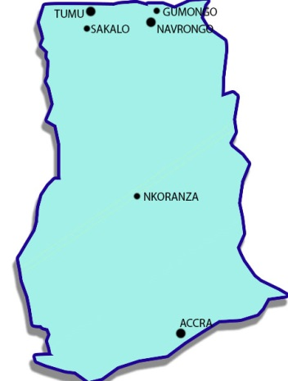
EMA missionaries continue to engage in evangelism and church planting because that is their calling. There are currently eleven (11) missionary families and a director with the ministry. A brochure prepared in 2015 seeks to highlight the missionary families and their places of ministry. The following is a brief description of their missionary activities and the modest gains:

Thomas Abugah
He is the current EMA Director. He is married to Elizabeth Abugah since 1985 and they have five children – John, Joshua, Emmanuel, Ebenezer and Rebecca. He became a Christian in 1980 in Chiana in the Upper East Region of Ghana. The men of God who influenced his conversion included Rev. Peter Jenkins of SIM and Rev. Francis Kupoe. He accepted Jesus Christ as Lord and Saviour in Chiana in his hometown during his student days. He is a first generation Christian in his family. Bible verses that influenced his conversion include John 3:16 – 18, 5: 24, Rev. 3: 20. After hearing the Gospel preached and on reading these scriptures several times and for several days he invited Jesus Christ into his life. Soon after his conversion experience, he was baptised and became very active in his home church, the Kanania branch of the Fellowship of Good News Churches at the time. By the grace of the Lord, he grew up in his faith and became active in church activities during school vacations. Before his conversion, Thomas had thought that those who devoted themselves to serve God are the jobless. He had to change this mentality when the Lord gave him call to full time ministry came when he was a Science teacher at his former school in Bolgatanga (Big BOSS). At the same time, he got an invitation from the Ghana Armed Forces via two successive telegrams to attend an interview that was surely leading him to join the Ghana Armed Forces for an Officer Cadet Course. His senior at school, an officer in the Ghana Army, Captain Inusah Abdulai was willing to push this forward. To make a choice between these two opportunities was a big challenge. After much prayer the pull to join the Lord’s Spiritual Army was stronger so he accepted the call to the ministry and resigned from the teaching appointment. These infuriated his daddy Mr. Abugah who was expecting good returns for his investment his son’s education. Thomas attended Maranatha Bible College now (MUC) and later Christian Service College (CSUC) and was prepared for ministry.
Before then, he was the Shepherd of the Kanania church, and had oversight responsibility over Abulu and Nyangania churches. He ministered in other local churches in the Chiana DCC such as Saa, Asunia, Adasong, Yidania and Kaliviio. In 1991, he received a call to engage in evangelism and Church Planting. He therefore relocated with the family to Accra in October 1991. He formed a team with Raymond Lee of SIM and started local churches at Fianko, Jei Krodua, and Bontrase in the Central region. In May 1992, EMA was officially inaugurated. He joined the mission and became the Mid -Regions Coordinator. As a result he initiated and in some cases assisted in planting local churches at Mim, Goaso Nkawie, Nkawkaw and others. In 1994 he worked with Ray Lee to start a local church at Madina Zongo. In 1995, EMA transferred Thomas to Kumasi. Whilst in this city, he collaborated with Simon Azupe to transform the preaching point at Ntanaso into a local church. In1999, evangelism was scaled up leading to the beginning of a local church at Kaase, now Hope GNBC. And in 2004, in partnership with the late George Abazogao the Techiman church was started.
In 2006, he was appointed the Director of EMA to fulfill the following mandate: administration, visitation to mission fields, survey places for ministry, organise training sessions for missionaries, promote the mission and seek to raise funds for ministry etc. He served in this capacity until he got a study leave from 2009 – 2011. He was re-appointed the EMA Director in January 2014. By the grace of the Lord Jesus Christ, he is gradually fulfilling this mandate. He is not glued to an office but more active on the field and he has collaborated with local church leaders to start preaching points at Asunkwa, Poposo, and Bodoworo etc.

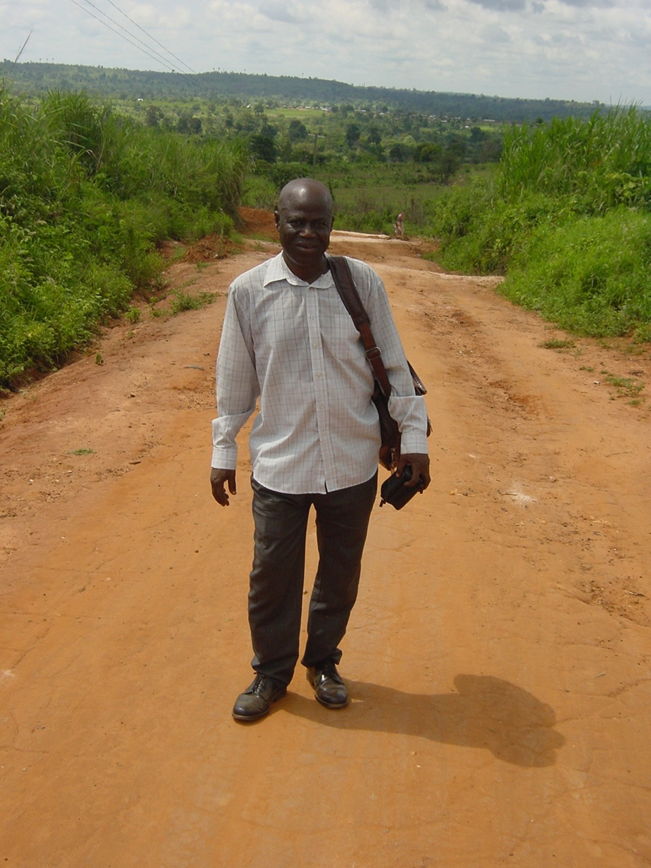
EMA Director, Rev. Thomas Abugah on ministry trip to Natanaso, by foot for a distance of 7 miles in.

2. Edward Alemya:
Rev. Edward Alemya was born on 10 February 1969 at Manyoro – Gumongo in the Upper East Region of Ghana. He became a Christian in 1984 via the ministry of Challenge Cinema Today. This Cine Van ministry showed a film entitled “Pilgrim’s Progress” in his village at the time. The film challenged him to see his sinful nature and the inability to save him from sin and its penalty. This moved him to respond to the altar call and he prayed and received Jesus Christ as Lord and Saviour. Shortly after this dramatic experience he joined the local branch of the Good News Church.

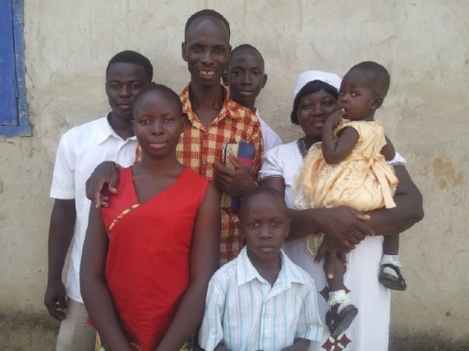
He was consequently baptised in February 1985. He soon became one of the leaders and to sharpen his leadership skills, he enrolled for the local Theological Education Text (TEE) course and completed some of the courses.
In 1997, he married Comfort and they have four children – Jedidah, Jason, Ephraim and Precious. All these are at different levels of schooling. Edward heard the Lord’s call to the pastoral ministry. In his response, he decided to sharpen his skills further and so enrolled at Maranatha Bible College and earned a Certificate in Theology. He served as a pastor for some time and was elected as the District Church Council Chairman at a point in time. In the year 2000 he had a call to evangelism and missions so he was recruited by EMA to be a missionary. He was relocated to Nkoranza in the Brong Ahafo Region to engage in cross- cultural missions. Unfortunately, he had a health condition that was allergic to the environment. He was therefore relocated to Tumu in the Upper West Region to continue with cross-cultural missions in 2006. His ministry in this town is evangelism and church planting as well as leadership development. There are outreach programmes to Sakalo, Bandei and Gwanduano. People are responding to the Gospel and those who believe are being organised to worship the Lord.
3. Emmanuel Yakijo
Emmanuel Yakijo joined EMA in 2013. He works in the Makayili area and his ministry is to both Dagomba and Konkomba ethnic people.The name of the town literally means “house of Mecca.” This could mean that either some one from a pilgrimage to Mecca in Saudi Arabia first settled in the place or a recognized Muslim has an influence in the place.Emmanuel is engaged in evangelism and organizing converts into local churches. This has resulted in the starting of some local groups. These include Nakpo in 2014. He has baptised some converts here. Another group is located in Makayili where he is stationed. The church here was started in 2015 and baptism has already taken place. There is some leadership in place to cater for the church. So the church is growing in spiritual maturity and numerically. Now there are ten more converts who are being prepared for baptism this year. An unfortunate incident that happened in Emmanuel’s ministry is that a woman who was his disciple and a teacher with the Children’s ministry in the Nmakando church had a home call by the Lord on 23 April 2017. The family members refused to hand over the corpse to the church for a Christian funeral service and burial. This action caused some problems for the church but things are returning to normalcy.
Another unfortunate incident in his ministry is that thieves broke into his new house provided by the Yendi DCC and other stakeholders in June 2017. These “second owners” made away with essential items such as mobile phones, clothing and other personal belongings. However this did not scare Emmanuel. He is still deeply involved in the ministry. He also has a ministry in Kakpuni and is preparing seven people for baptism here. He is now targeting a town called Yapala for a new ministry. This is a big challenge because he must cover a distance of fifteen kilometres one way and his motor -bike that he has bought prior to joining EMA is now old and is no longer working well. He has to replace several parts on it –tyres and tubes, piston and rings, battery, overhaul the engine and so on. EMA is looking for the finances to maintain this machine and make a replacement. We keep trusting the Lord for this.

David Neindow: He was a Muslim before He encountered Jesus Christ. He narrates the circumstances that led to his conversion to Christianity. He attributes his conversion experience to what his Christian brother Pastor Fusheini did. He says, “My brother, Pastor Fusheini is a Christian and used to give me Christian books to read about Christianity.” Neindow read these books for some time and became convinced by what he read. He sought to know more about what he read - the meaning of the contents of the books. He decided to go to church on Sunday. He says, “One Saturday when we were working together on the farm and I told my brother that the next day being Sunday I will give my life to Christ. He himself didn’t believe what I was saying because he knew that I was a Muslim and I was serious in reading the Quran”. Moreover, his brother shared the Gospel with Neindow and the text he used is Matt. 25: 25-34. Neindow accepted Jesus as personal Lord and Saviour on 17th August 1997 at his hometown, Sambu on the Tamale – Yendi road.
After this dramatic event he gradually studied the Bible, prayed and had fellowship with his local church and continued to mature as a Christian. With regards to his ministry experience, he was called to the pastoral ministry. He enrolled at the local Bible Training Centre in Chiana in 2002 and completed in 2003. He was married to Lukaya on 23rd December 2006 and they gave birth to a baby boy called Daniel in 2008.Unfortunately, Lukaya who passed away on 21st February 2011. He was posted to Sang to pastor a church in 2007. He served in this capacity until he received another call to evangelism and church planting in February 2015.
He applied to EMA and was recruited into the ministry. His ministry comes at a time when we need to actively engage the Muslims with the Gospel. His mission station is Sakpei and its surrounding villages. The Islamic influence in this town is strong. This means that he has to engage Islam and the Traditional Religion in his ministry.
He has already started a preaching point each in two villages - Kpunkpono and Nasoniwulana Kuraa. The other groups started include Nasoni where 5 meet on Sundays; Fusheini Kura where 6 meet on Sundays and Bladem Kura and 5 people meet here. In Sakpei, meetings are held on other days but few come to Sunday meetings because of the fear of reproach by family members. Some of these are being prepared for the rite of baptism. Islam has an influence here. David continues to visit homes and shares the message. People promise to come to the Sunday meetings but sometimes are not able because of fear. We continue to pray for a breakthrough in Muslim evangelism.
David has remarried since September 2016. His spouse is Fusheina and they have a child named Elijah, born on 7 September 2017. His in-laws are Christians and the father in law is the Board Chairman of a certain church. We praise the Lord for this development.

John Kampale and ministry in Burkina Faso: EMA has a ministry in the Southern part of Burkina Faso. John Kampale is the church planter here. He hails from Manyoro in the Upper East Regiom of Ghana.and is married to Akwiah and they have four children – Hannah, Joseph, Isaiah and Deborah. John became a Christian about twenty years ago. He narrates how he became a Christian as follows: “One day in 1995, I saw an old time friend of mine called Titus Alo with his Bible going to church on a Sunday. I asked him where he was going and he told me that he was for church. When I heard this I told him that he is not a good friend because he has found a good treasure and was hiding it from me. He said he was sorry and invited me to church service that day. I made a few visits to the church, walking the long distance across the Ghana – Burkina border into Tangasugo for church services each week. At one of the services, the preacher told the audience that Jesus died for the sins of all humankind including me and read these verses: John 3:16; Rom. 5:8; 1 Tim. 1:15. When I heard this, I asked how I could become a child of Jesus. I was told to believe in Him and receive Him into my heart. I was led to pray the sinner’s prayer and hence invited Jesus into my life. Since then my life has not been the same. I have been changed and I have joy in my heart because I am now a child of God.”
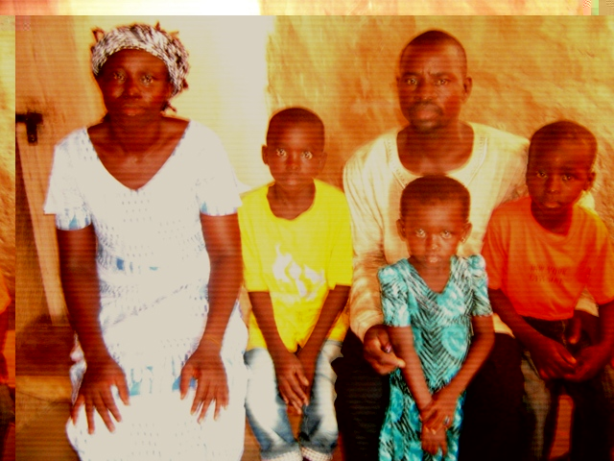
After John became a believer in Christ, he was zealous to serve the Lord and soon became a Sunday school teacher. After serving the Lord in this ministry he had a call to evangelism and church planting. He applied to EMA and was recruited in 2010 to work in the southern part of Burkina Faso.
He has ministries in Chibeli Kolo, Bungu and Kampala where he is sharing the Gospel. There is some response. At a village called Kamanchilo the traditional authorities are afraid that his preaching of the Gospel will cause a serious problem to their customs, beliefs and gods and hence had a negative encounter with him. At one time they even stopped him from visiting the town for a while. John however believes that these people need the Gospel the most and he is praying and strategising to minister effectively in this village. Other towns and villages on the list to be evangelised include Po, Ziku, Yeliwongo, and Kayaa. These places are quite distant from each other and EMA is seeking funding to purchase a strong motor -bike for him. There is no public means of transport in this part of Burkina. EMA is seeking to recruit two more church planters to work in these places if funding is available. There are relatively few church groups in these villages and in cases none at all. The harvest is ready here but the labourers are few.
Pray that the Lord will send workers and into this harvest field (Lk. 10:2). We are humbly asking partners to pray that the Lord sends the material or financial resources into the harvest field. EMA has a mission house on a piece of land we acquired in Tangasugo. Now the house has fallen down and needs to be pulled down and rebuilt for ministry. The landlord is asking us to do so soon because if he goes to his forefathers, then we may lose the land to his sons. We are praying for the resources to tackle this issue. This will hopefully boost EMA ministry in Burkina Faso.

Joseph Agana: He is our church planter in the Overseas Area. This was a very remote part but development has is taking place in this area in the past five years. This place was formerly part of the Mamprusi West District Assemby. The area under consideration is the Mamprugu Moaduri District (that is Mamprugu – an ethnic group – that lives near or across the river). The District Capital is Yageba, a potential tourist destination because of its slave market during the slave trade era. It was a small place but has in the past five or so years expanded because of its status as the capital of the newly created District. This is where Joseph was stationed to do ministry. We have transferred Joseph to a small town called Gyadem. He has found accommodation here and he is sharing the Gospel in this small town and its environs. The response is good and his ministry here is growing. A total of 15 new converts were baptised recently. He has recently started a ministry in Bugyinga, a village with some Islamic influence. The traditional religion is also strong. Joseph reports of a stiff power encounter in his ministry here. However, the ministry started with four adults and the number is now gradually increasing each week at the Bible study and prayer meetings. They also meet on Sundays for services. Meanwhile the local churches he had started earlier such as Zamwara and Sageya are under the care of local leaders. The DCC is working hard to resolve a leadership issue in the Yageba church after Agana’s relocation.

Peter Dawuni: Peter and Stella are now targeting the village of Kpatarugu with the Gospel. There is a good response and members in this group are being prepared for baptism. He visits them on regular basis each week to share the Gospel and hold prayer meetings. Some of them do testify to the transforming power of the Word of God in their lives. According to them, they are experiencing a change in their lives. Before their conversion they were disobedient to the Lord and indulged in actions that are contrary to the Bible, but now this is no more. The number at Kpatorigu on Sundays is increasing by the day and those who confess Christ as Lord and Saviour are on the increase. Peter has to ride his motor -bike cross the River Volta and other rivers to do ministry. He at times gets into difficulty. He is on the job. Meanwhile the local churches he started at Kubugu, Bugisa, Mankarugu and Mempeasem are growing in numbers and in spirit.

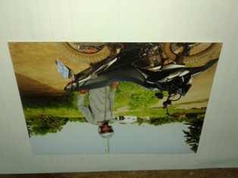
Peter crosses the River Volta on his motor bike to do ministry.

Edward Amolikado and his wife are ministering in a village called Yipabongo. He has ministries in Tuvu and Tando. Besides, he also has a ministry in Dabezisi. In each of these, he teaches Bible study and is focused in making them believers in Christ by preparing them for baptism so that they become real and committed disciples Meanwhile the fruit of his ministry can be seen in the local churches at Yipabongo,Tantoosi and Tantale. In Tantale, ten believers in Jesus were baptised recently. Local leaders cater for these groups. However. He occasionally visits them to give encouragement. He is on the list of missionaries who will be relocated to new places for ministry this year when we secure the needed

Walewale Ministry – George Akumzidi: Walewale is the Capital of the West Mamprusi District in the Northern Region of Ghana. This is a Muslim dominated township and mosques can be seen in numbers in every corner. Peter and his wife Stella were transferred to this area in 2009. Stella has asthma and this condition is allergic to certain plants or flowers in the environment. Hence, after three years of ministry here, we had to transfer this family to Yageba in 2012. They had a flourishing ministry at the time and started a group that met on regular basis for Bible study and prayer. They assisted the group to acquire a piece of land to be used for constructing a chapel. Since the time they left, the ministry here is struggling due to lack of effective or committed leadership. We intend to revive the fellowship and transform it into a church by placing another cross – cultural missionary in the town. He is in the person of George Azibasoma Akumzidi, currently stationed in Chuchuliga. George has started in his station and now intend to transfer him to Walewale to revive the group here who no longer meeting because of the leadership issue. He has accepted the challenge to move into the town. This will hopefully take place in 2018 when we are able to put the logistic / support together. We will need decent accommodation for the George and his family, monthly allowance for urban ministries etc. The town is a fast growing Municipality. Islam poses a great challenge to Christian witness in this town and others in the north of the country. Muslims like any other persons are lost in sin and hence need to repent and receive new life in Jesus Christ. This will happen if they hear the message of salvation in Christ. And they can only hear if someone preaches the Gospel to them {Rom. 10: 9 -10). This has been one of the burdens on the hearts of EMA administration and our church planters on the field.
Thomas Pwalia: Thomas Pwalia joined EMA as a church planter in April 2005 and was relocated from Chiana – Kayero to Kumasi. He ministered so effectively such that in within three years, he started local churches at Abrepo and Atwima Koforidua as earlier mentioned. These are growing churches with effective local leadership in place. Two leaders from the Abrepo branch have been trained at the Bible Training Centre (BTC) in Chiana between 2015 and 2016. One also received training at the Christian Service University College in 2015 and one has entered the BTC in January 2018. From Atwima Koforidua, two leaders have also graduated with a Certificate in Biblical Studies from the Christian Service University College. It is our prayer and desire that churches started by our church planters follow this pattern.
Thomas led a group of church leaders to start evangelism in Mankranso. The Director assisted with weekly visitations and a video show that resulted in organising the believers into a fellowship in May 2015.who meet regularly on Sundays for church services and week days for Bible Study and prayer. They are growing in spiritual maturity and in number. Three converts were baptised on 7 January 2018 by Thomas Pwalia. More will be baptised in March this year also during the Easter. After this, the group will formally be recognised as a local church by the Kumasi West District Church. Meanwhile, the DCC and the EMA Director have made David Pwachoa, one of the trained leaders from Atwima Koforidua to work with the group and he does well. The group has grown in numerical strength since the beginning of 2018. From an average of 16 on Sundays in 2017, the number is now grown to over 30. The group organised a New Year party on 7 January 2018 and invited the Director to assist in explaining a video on the Life of Jesus Christ. Newcomers were invited and since then they are still with the group and some have given their lives to Jesus.
The Director and some leaders have visited a town to the north-east of Mankranso called Kunsu for initial survey work. It is about five miles away from Mankranso. Some contacts have been made so far and it is hoped that Pwalia will scale up visitations to the town this year for the start of serious formal meetings for Bible study. The Director has encouraged those contacted so far to join the Mankrano group for Sunday services until they are able to meet alone.

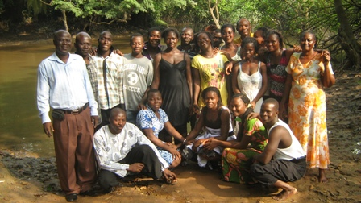
EMA Director (left) with converts for Baptism posed for a photo before the immersion.

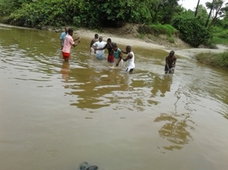
Pwalia being assisted by a church leader to baptise converts

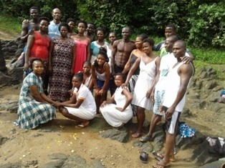
Baptised converts with Pwalia (at back).

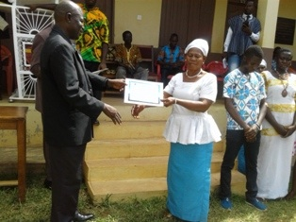
Madam Talata, a new convert receives baptismal card from Thomas Abugah, EMA Director

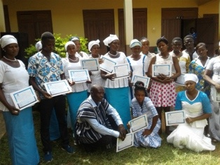
Baptised converts display their cards with joy in the Lord
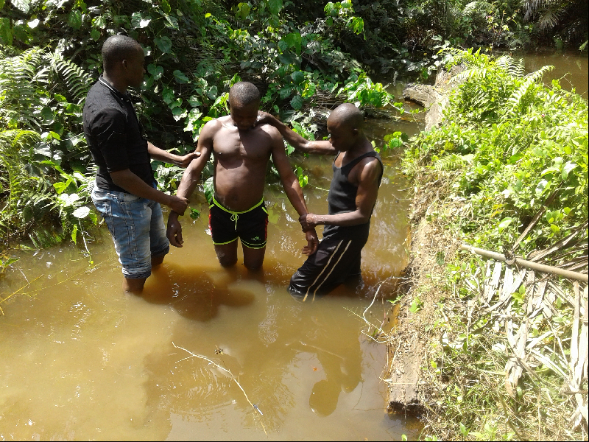
Baptism of Atta Batowo of Bodoworo fellowship

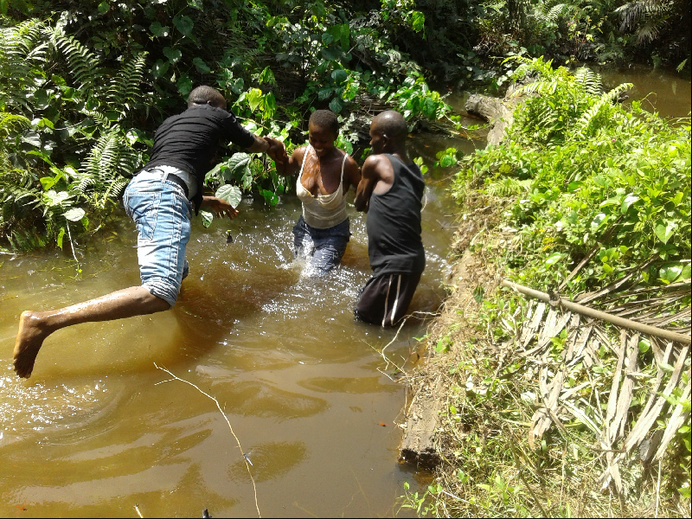
Baptism of Dora Bayoo of Bodoworo fellowship

Michael Aketado Ayuekambe: He is married to Comfort and they joined the ministry in 1994. He ministered in Madina and helped the church Thomas Abugah stated in that year to grow and also in Suhum. He then started local groups in Oboum, Swedru, Winneba, Cape Coast and Jei Krodua all in the Central Region when he relocated from Accra to Kasoa. Michael will complete a four year Batchelor of Arts in Theology programme in May this year and graduate in December. He plans to target new places with the Gospel after this.

George Babawedoe Funah:
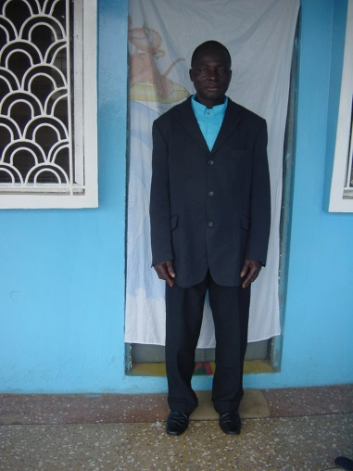
He joined the ministry as a church planter in February 1992. He stays in an a place that is far removed from other towns because the roads are deplorable and cars scarcely go there besides on a market day that comes on once each week. There is no communication link here so George is always in a ‘black out” regarding communications. One local church was started in Kweku Attakrom where George resides. Two other local churches were started, in Enchi and in Nyame Boame, 50 km and 70 km respectively away from where resides. The Enchi groups no longer meeting and George is working hard to revive them. George had tried to relocate to Enchi a few years ago but financial constraints on EMA have caused the landlord to take back his room he had rented out to George. Please pray for the Lord’s provision for this need. He has plans to take the Gospel to the following towns and villages: Yakese, Akontombora, Yuabra, Asankragua.

Designation of EMA Ministry
The ministry has been divided into the following settings, with regards to the location of the ministry. There is the urban missionary who is stationed in big towns or cities with busy commercial activities, high populations and hence high cost of living. He has to grapple with the busyness of life daily.
The next category is the rural missionary who is in the village or small town. EMA shall revisit the appointment of coordinators to assist in the oversight of the church planters. The ministry has been divided into: EMA South (Eastern Region, Greater Accra, Volta and Central), Mid regions (Ashanti, Western, Brong Ahafo) and EMA North (Northern and Upper Regions). Each zone or sector / region will be managed by a Coordinator who shall be responsible to the Director.

EMA Financial Needs
The needs are many. We will need funding to finance the following aspects of our annual budget and the budget explains indicates these.
- Living allowances each month for missionaries, Director and office staff
- Transportation / travel
- Maintenance of motor -bikes / replacements etc.
- Training / conferences/ seminars
- Medicals
- Administration
- Accommodation / housing
- Stationary supplies
- Board meetings
- Car for use of the Director etc.

Plans
- Encourage individuals and local churches to be part of the missions agenda in prayer and financial support at the local level.
- Seek partnership with like -minded individuals and organizations within and outside Ghana.
- Plan with the NCC for a missions conference.
- Hold an effective EMA missionary seminar in the year.
- Survey new places for evangelism and church planting.
- Assist church planters to bring up the various preaching points or fellowship and transform them into local churches – Kpatarigu, Buyinga, Dabezesi, Kunsu, Obuasi, Sepe, Fusheini Kura, Sakpei, etc.
- Recruit at 6 more church planters from 2019 when there is available funding.
- Seek to place a missionary in the Volta Region between 2018 and 2019.
- Appoint sector coordinators for the ministry.

Conclusion
We are thankful to the Lord Jesus Christ for the modest gains so far. We remain grateful also to the leadership of the GNBC who are solidly behind this ministry with all their hearts and prayers. There is surely more to be done what than has been done. We pray to the Lord to send in both the harvesters as well as the financial and material resources to gather in the harvest. May He accomplish His Will using us as empty vessels. Amen!

Praises & Prayer Requests
Praise the Lord for His workers – EMA missionaries in the ministry of evangelism and church planting.
- Praise the Lord for the modest gains.
- Pray for the ministry needs of EMA – financial / material.
- Pray for the growth of the groups that have been started so far.
- Pray for an expansion of the ministry. There is need to place one missionary in the Volta Region where the traditional religion is strong.

